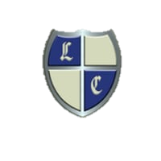

WELCOME TO LANGHAM COURT

**IMPORTANT INFORMATION FOR OUR GUESTS**

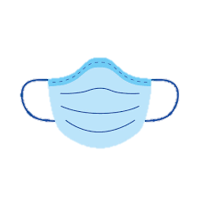We would like to tell you of some of the things we have put into place to keep our guests and staff safe at Langham Court.

Please help us to keep you, other guests and staff safe by wearing masks in all public areas of the hotel, except when at tables eating or drinking and of course in your room.

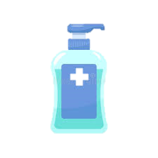

Please use the hand sanitizer every time you enter the hotel.

We are frequently wiping all hand surfaces and spraying in the hotel.

Please follow social distancing where ever possible.

We have a one-way system in operation; up in the lift down on the stairs. If you have a difficulty

with stairs please use the lift.

There are sanitizing stations around the hotel for your use.

We are using individual packets wherever possible any unused packets will be disposed of, if you would like to take them with you please do so.

**Housekeeping:**

It would be appreciated if guests would use only their own rooms and not visit other rooms during their stay.

Laundry is done at 60°C with anti-bacterial liquid for extra safety.

As an extra precaution when rooms are vacated we steam clean them and leave them for 72 hours before using them again.

All staff have PPE.

We are looking forward to you arriving.

Covid-19- Find out what we are doing differently to keep you/our guests safe. safe.